CE 319F – ELEMENTARY MECHANICS OF FLUIDS
SPRING 2009
LAB NO. 3: FLOW VISUALIZATION USING PIV

Objective:
The objective of this lab is to visualize the flow around a cylinder using the Time-Resolved Particle Image Velocimetry (TR-PIV) system.

Introduction:
Particle Image Velocimetry (PIV) is an optical field technology used to measure instantaneous velocity and related fluid properties. Velocity measurements are typically made with the help of seeding particles by suspending them in the fluid in motion. The system gains information on particle displacements in the fluid over a known interval of time. The velocity is calculated in accordance to the relationship:

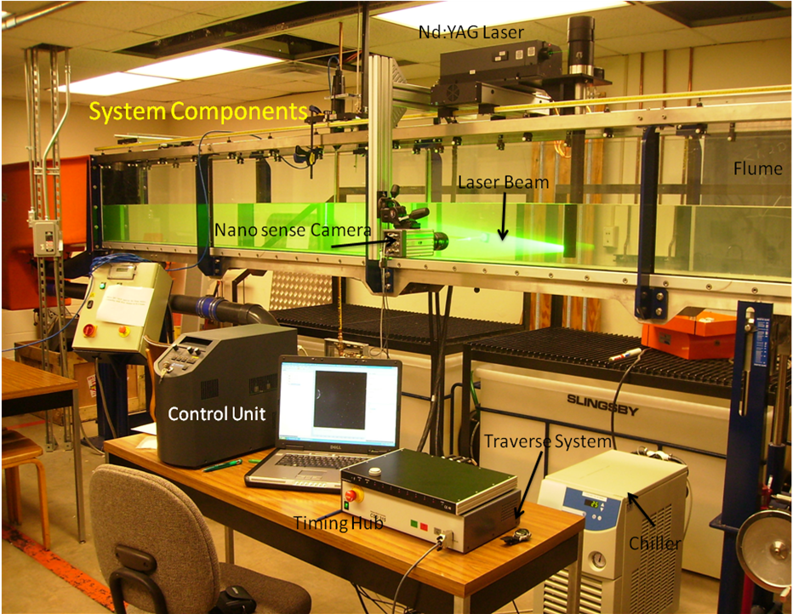

Figure 1: System Components
Typically, the PIV system consists of a light source, Nd:YAG Laser in our lab, and a nano sense camera. Both the laser and the camera are synchronized such that when the seeding particles are illuminated at the instant of light pulse, the camera captures the image. The software then stores the data and enables further processing giving various plots, maps and statistics of the flow visualized.

The components of the TR- PIV system are as follows:
- Nd: YAG (neodymium-doped Yttrium Aluminium Garnet; Nd:Y₃Al₅O₁₂) Laser
- Nano sense camera
- Timing Hub
- Chiller
- Control unit
- Traverse system
- Flume and pump

Procedure:
Acquisition system
The major role in the PIV system is that played by the Laser and the Nano-sense Camera. Our system consists of a double cavity Q-switched laser. Energy is built in the 2 cavities and is released over a short duration of time (around 4-10 nano sec), providing powerful light flashes required for illumination of the seeding particles. The delay between the laser flash from cavity 1 and cavity 2 corresponds then to the time between two images capturing particle positions.

The Nano-sense camera enables to take user defined number of images and can be operated in singe frame or double frame mode. In single frame mode both the light sheet pulses are recorded on the same frame whereas in the double frame mode they are recorded on two frames. Double frame mode is advantageous since it enables to enhance the analysis by performing cross-correlations.

Flow Visualization:
For this lab, the set-up consists of a cylindrical glass rod secured in the flume. Flow around the cylinder can be easily visualized with the help of the laser which illuminates the seeding particles. The camera is operated in the Free run/ preview mode to observe the flow closely.

Processing the data
For evaluation of the data, each image is divided into M*N pixels interrogation areas. The software tracks the particles in each image and establishes a correlation function. Interrogation areas are correlated to produce average particle displacement vectors. Transforming Camera displacements (in pixels) to physical dimensions (in mm) and dividing by the time between the two frames captured, displacement vectors are converted into a map of raw velocity vectors.
The processing stages can be summarized in Fig. 2.

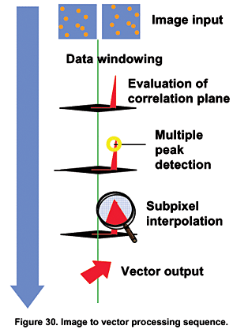
Figure 2. PIV Processing Stages

Correlations and filters:
Different types of correlations such as adaptive, cross and average correlations are applied and refined data is obtained. Further, filters are used to output vector maps by arithmatic averaging and individual vectors are smoothened out. Incnsistent vectors can be substituted by taking weighted average over a user defined area.
In short, all the validation algorithms are to fine tune the processing , remove spurious vectors and to improve acquired parent dataset.

Seeding particles:
Since water particles are tranperant, we need to put in some kind of particles to Visualize the flow. The seeding particles we use are silver coated very fine spherical glass particles having a diameter of 50 µm. Their diameter shall be comparable to that of the light source wavelength.
Other important characteristics of the seeding particles-
- They must be neutrally bouyant in water
- Must scatter reasonable amount of light sideways
- Must be chemically inactive
- In optimum amount.

Conclusion:
The PIV system is an effective tool enabling Flow visualization and determination of fluid properties. PIV system can be used fairly easily to depict the flow charachteristics around objects such as cylinders.

Safety Precautions:
- Nd:YAG lasers are classified as class 4 radiation hazards and hence any direct eye, skin contact with it shall be avoided.
- Any reflecting materials such as metallic watches and rings shall not be used while performing the experiment.

